Central Focus: Be a disciple who makes disciple makers.
To fulfill the Great Commission by multiplying prayer, disciples, leaders, and churches in Western Europe.
Central Focus: Be a disciple who makes disciple makers.

Enter Ministry Team Vision
Ministry Team Vision:
Enter Field Team Vision
Enter 5-Year Priorities
Enter 1-Year Goals
Enter 90-Day Tasks
90-Day Tasks
1-Year Goals
5-Year Priorities
Preferred Culture Values:
• Jesus is first
• Gospel is celebrated
• Biblical family atmosphere
• Humble confidence
• Sharing lives and possessions
Guiding Principles:
• Cultural Intelligence
• Developing Leaders
• Holistic Ministry
• Networking &
Partnering
Field Team Vision:
Regional Vision:
To fulfill the Great Commission by multiplying
leaders, churches, and missions movements among every people.

Ministry Team - Strategic Planning Tool Worksheet
ABWE Global Vision:
5-Year Priorities
Ministry Team - Strategic Planning Tool
- Priorities are prayer Priorities. They are faith based and Prayer focused; God must complete the work.
- These are things we desire to see happen to advance the gospel and are specifically asking God in faith to accomplish if it is His will. Priorities should be God sized and beyond what we can accomplish in our own strength.
- Priorities are chosen so that everyone can unite in prayer around these Priorities. There could be several Priorities.
- Examples: Identifying needs, identify a recruitment need on your ministry team.
- Involve existing ministries and new ministries.
- Existing ministries: Seeing a need for the ministry to be expanded.
- New ministries: Do not require detailed survey work to be done before setting them, they should be set in response to seeing a need for a gospel witness in a community (as a people or place) or a new ministry.
- Priorities should be revisited once every year or two, and will guide in the creation of specific annual goals.
- These are the long-term priorities that the Ministry Team has established which are necessary in order to accomplish the Ministry Team vision.
- While not all of the required personnel and resources to fulfill these priorities may be in place at this time, establishing long-term priorities can be helpful in identifying the kind of new team members that will need to be recruited and the resources that will need to be created or obtained.
- Priorities may involve the whole Ministry Team or a Missionary Unit.
Set Ministry Team 5-Year Priorities by asking:
- What ministry growth are we praying for in the next 5 years?
- What needs are we praying that God will help us meet in the next 5 years?
- What communities (as a people or as a place, new or existing) are we praying for an open door for the gospel?

1-Year Goals
- Actions to be completed in the next year
- Ways we believe God is leading us to obey the command to go and multiply disciples, leaders and churches.
- Example: If the Field Team chooses a new church plant location as their Priority, then Goals could be survey work, putting the need on the ABWE website, committed times of prayer, etc.
- Obedience based; they are our part in God’s work.
- Set each year.
- Should be specific, measurable, achievable, relevant, and time-bound.
- Examples: If the Ministry Team sets a Priority of reaching a community (as a people or place), then Goals could be the ways you want to make inroads into that community or group. If a Priority was seeing leaders developed in the church, a Goal could be meeting monthly with individuals who are potential leaders.
- Missionary Units can use these Ministry Team goals as part of their annual ABWE report.

Set Ministry Team Goals by asking:
  - In the next year, what things can be done to help us move towards our 5-year Priorities?
  - What will I/we do in the next year to multiply disciples, leaders, and churches?
  - What will I/we do to be a disciple that makes disciple makers?
Other helpful questions:
What will I/we do in the next year…
  - to connect and share hope with unbelievers in the communities we are praying for?
  - to disciple believers to obey and equip them to multiply?
  - to mentor, coach and develop people to lead?
  - to simplify our church to help it multiply?
  - to collaborate with others to help multiply churches? (Collaboration could be with Field Team, local ministries, or other missionaries/agencies)
  - to strengthen, support or equip others in the work of ministry?
  - to develop ourselves to be better prepared and equipped to fulfill the ministry? (Reading, workshops, courses, classes, mentoring, coaching, etc.)

90-Day Tasks
- Tasks are the practical next steps to fulfill the 1-year Goals.
- Set Tasks (next steps) at the beginning of each year.
- Review Tasks every 90 days to improve focus and evaluate progress towards the goal. Make any necessary tweaks.
- Example: If a Ministry Team chooses a goal of connecting with unbelievers in a community using ESL, tasks could be to find curriculum, survey the need, plan a 3 month trial run, etc.
- If there is more than one Missionary Unit on the Ministry Team, clarification on who is responsible for the task may be necessary.
- Many of these tasks may flow from your application of the Field Team and Ministry Team Goals.
Set 90-Day Tasks by asking:
  - What are my/our next practical steps to fulfill the 1-year Goals?

Evaluate. Adapt.
To evaluate your plan, answer the following questions:
- What new challenges and circumstances are we facing?
- Is the Central Focus central?
- Because of new challenges, circumstances or understanding, what do we need to adapt to fulfill our Vision and Central Focus?
- Do our regional, field, and ministry team vision statements align with the global ABWE vision?
- Are the ABWE preferred culture values and guiding principles reflected in our priorities and goals?
- Are our 1-year goals specific, measurable, achievable, relevant, and time-bound?
- Have all of our 90-day tasks been assigned to a member of the team if necessary?

Western Europe Vision

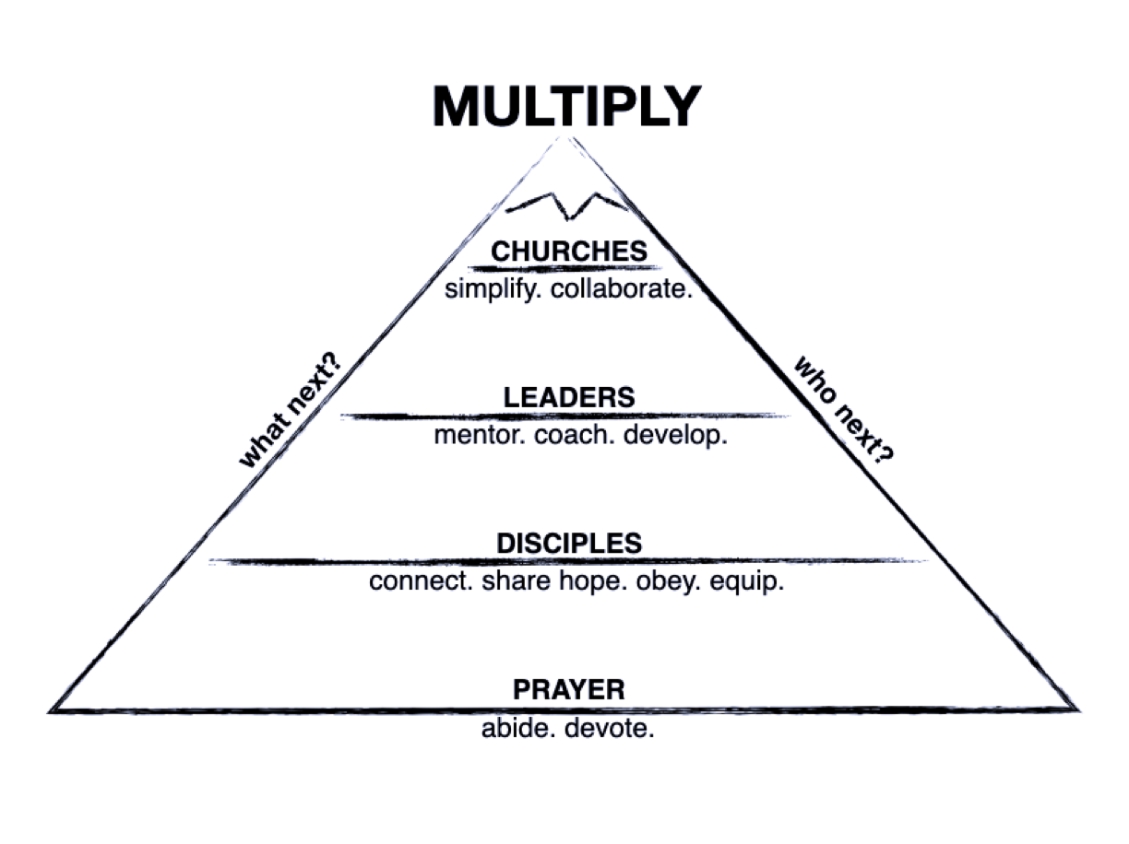
Central Focus: Be a disciple who makes disciple makers.

